Remove Password from Excel VBA

<https://superuser.com/questions/807926/how-to-bypass-the-vba-project-password-from-excel>

https://www.onlinehexeditor.com/

For older .XLS files:

1. Open file in any hex editor
2. Search for the text "**DPB=**" (no quotes, you should find it just above "[Host Extender Info]"

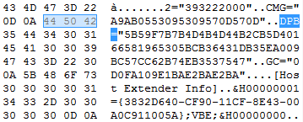

1. Change it to "**DPx=**", save and close the file

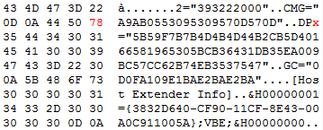

1. Open the file in Excel and press Yes if the following warning pops up:

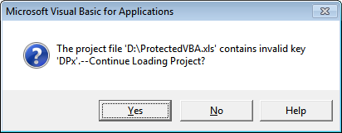

1. Open the VBA editor (Alt+F11) and press OK whenever the following warning pops up:

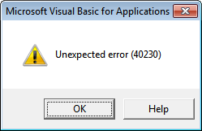

1. Right-click the VBA project name, select *Properties*, go to the *Protection* tab and delete the existing passwords as well as uncheck the **Lock project for viewing** checkbox:

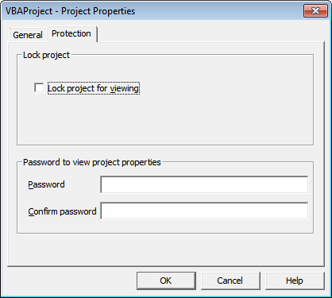

1. Re-check the **Lock project for viewing** checkbox and add your own memorable password.
2. OK your way out and now the VBA code is accessible!

For newer .XLSM files:

1. Change the file's extension to .ZIP
2. Open the file in any archiver such as WinRAR or 7-Zip and you'll see the following directory structure:

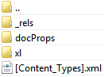

1. Go into the *xl* directory and extract **vbaProject.bin**:

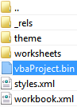

1. Perform steps #1-3 above (*from the****For older .XLS files****section*) with **vbaProject.bin**
2. Replace the old **vbaProject.bin** in the ZIP file with the new hex edited version
3. Change the file's extension back to .XLSM
4. Perform steps #4-7 above